**PCB WORKSHOP**

CIRCUIT DESIGNING AND IMPLEMENTATION WORKSHOP

# 

**REPORTED BY : TEAM LLM**

**GROUP DETAILS:**

1. Maruthi M
2. Lakshman B H
3. K Lokeshwar Reddy

REPORTED ON: 25/05/2024



## SIMULATION RESULTS:

1. LED ON-OFF

1. Description of the LED On-Off Simulation:

We have designed an LED on-off circuit using Tinkercad. The circuit includes the following components:

1. **Power Supply:** Set to deliver 5.00 V.
2. **Green LED:** Indicates current flow when illuminated.
3. **1kΩ Resistor:** Limits current to prevent damage to the LED.
4. **Slide Switch:** Controls the circuit, allowing it to be opened or closed.

During the simulation, the power supply continuously provides 5.00 V to the circuit. The resistor is connected in series with the green LED to limit the amount of current passing through the LED, thereby protecting it from excessive current. When the slide switch is closed, it completes the circuit, allowing current to flow from the power supply, through the resistor and LED, and then back to the ground. This current flow causes the LED to light up, indicating the circuit is active. The ammeter displays a current of 3.11 mA, verifying that the circuit is functioning correctly

(B) **TINKERCAD SIMULATION RESULT:**

**CIRCUIT LAYOUT**

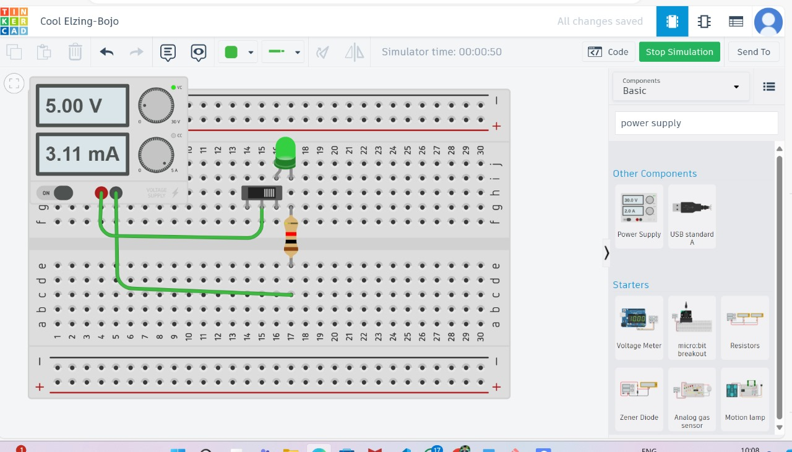

**SCHEMATIC DIAGRAM**

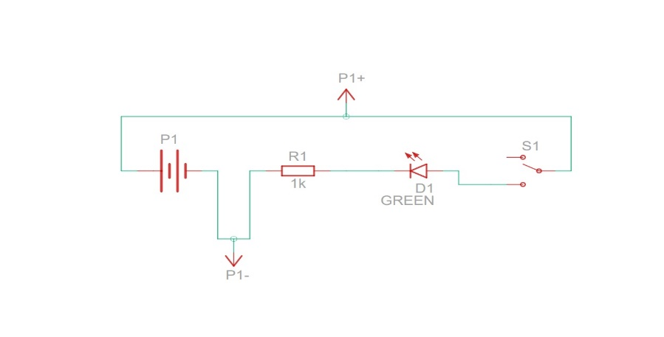

**COMPONENTS**

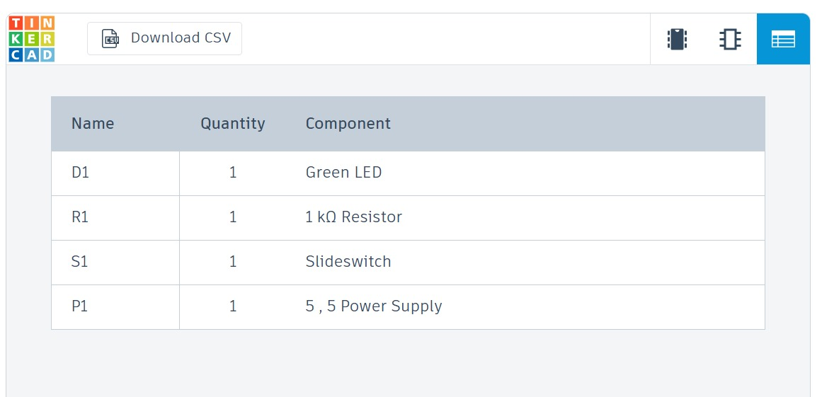

**CIRCUIT BUILDING ON ON PCB BOARD.**

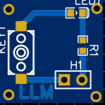

**2. HALF ADDER**

This simulation demonstrates a half-adder circuit built on a breadboard.

* Components:
  + Integrated Circuits (ICs):
    - 74HC86 (quad XOR gate) for calculating the sum.
    - 74HC08 (quad AND gate) for generating the carry bit.
  + Resistors (1kΩ): to limit current for the LEDs
  + LEDs (red and green): to visually represent the sum (red) and carry (green) outputs
  + Power supply (5V): to energize the circuit
* Functionality:
  + The circuit adds two binary inputs (A and B) using the XOR and AND gates.
  + The XOR gate's output determines the sum, lighting the red LED when both inputs are high (1 + 1 = 1 with a carry) and vice versa.
  + The AND gate produces a carry output (green LED) only when both inputs are high.
  + A 2.99mA current measurement indicates normal LED operation.
* Key Points:
  + The circuit faithfully replicates the schematic, ensuring accurate behavior.
  + Digital gates have inherent propagation delays and potential glitches during input changes, which are present in this circuit.

This rewrite simplifies the text, emphasizes key points, and improves readability.

(B)**TINKERCAD SIMULATION RESULT:**

**CIRCUIT LAYOUT**

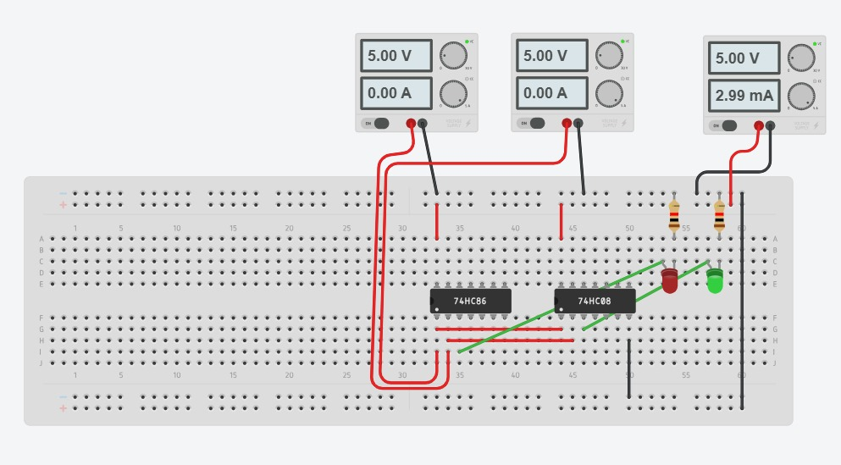

**SCHEMATIC DIAGRAM**

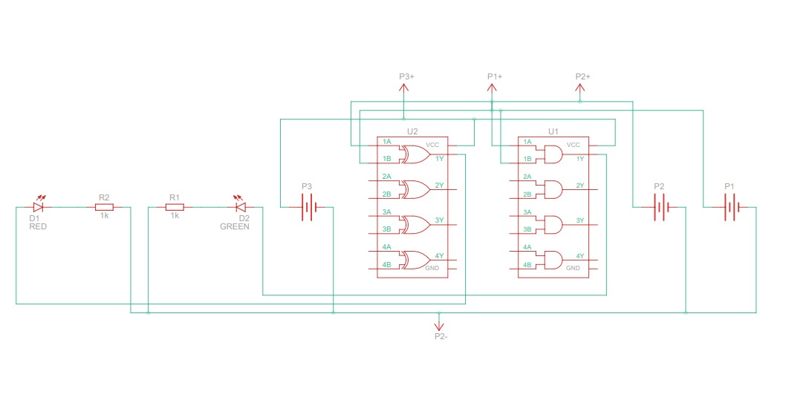

**COMPONENTS**

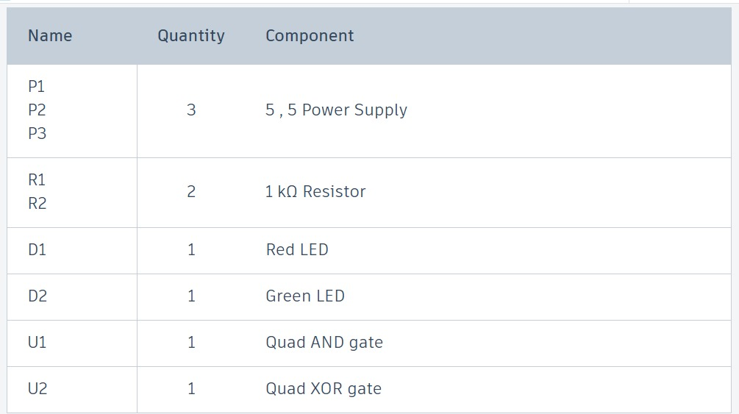

**CIRCUIT BUILDING ON EASYEDA (2D VIEW) ON PCB BOARD.**

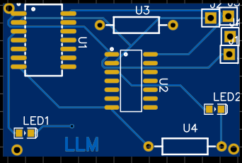

Transient Response:

The half-adder's response to input changes involves three key aspects:

* Output Logic:
  + The XOR gate calculates the sum based on exclusive OR logic. The connected LED reflects this by lighting up according to the input combination (red LED = sum).
  + The AND gate generates a carry output (green LED) only when both inputs are high (carry occurs when 1 + 1 = 1).
* Propagation Delay:
  + Switching the inputs takes time for the gates to settle and produce stable outputs. This delay, typically in nanoseconds for CMOS logic like the 74HC series, is inherent to digital circuits.
* behavior of the gates.

**3 . 555 TIMER IC**

**This simulation demonstrates an LED blinking circuit built with a 555 timer IC.**

* **Components:**
  + 555 timer IC (U1)
  + Resistors:
    - R1 (1kΩ)
    - R2 (1kΩ)
    - R3 (1kΩ)
  + Capacitor: C1 (100nF)
  + Power supply (P1) set to 9V
* **Functionality:**
  + The 555 timer is configured with resistors and a capacitor to generate a square wave output at pin 3.
  + The frequency of the blinking LED is determined by the values of R1, R2, and C1.
  + When the output at pin 3 is high, the LED turns on (red glow for most LEDs).
  + When the output goes low, the LED turns off, creating the blinking effect.
  + The breadboard layout matches the schematic for accurate operation.
* and C1.
* When the output at pin 3 is high, the LED turns on (red glow for most LEDs).
* When the output goes low, the LED turns off, creating the blinking effect.
* The breadboard layout matches the schematic for accurate operation.
* **Measurements:**
  + The power supply voltage is 9V as expected.
  + The current measurement indicates normal LED operation.
* **Explanation:**
  + The blinking is caused by the charging and discharging cycles of the capacitor, which control the switching of the 555 timer's output, ultimately turning the LED on and off.

(B)**TINKERCAD SIMULATION RESULT:**

**CIRCUIT LAYOUT**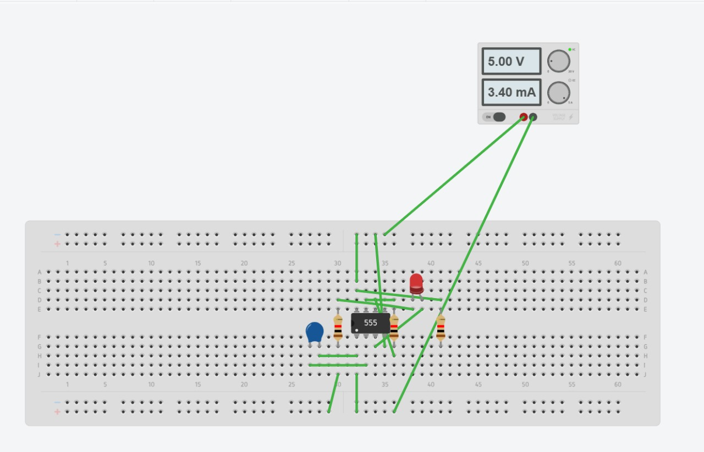

**SCHEMATIC DIAGRAM**

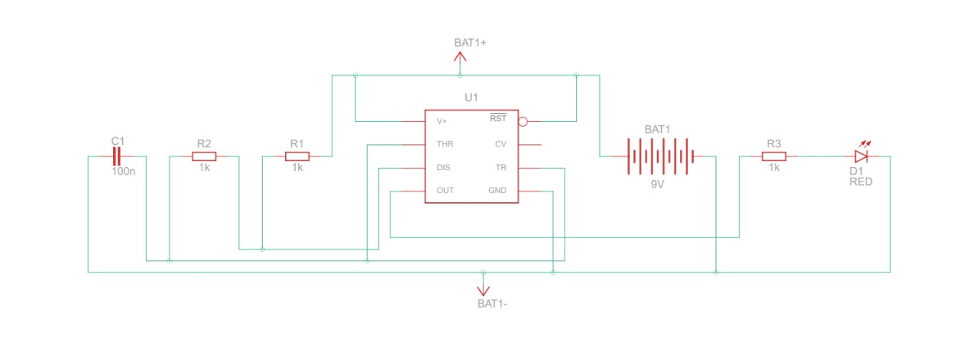

**COMPONENTS**

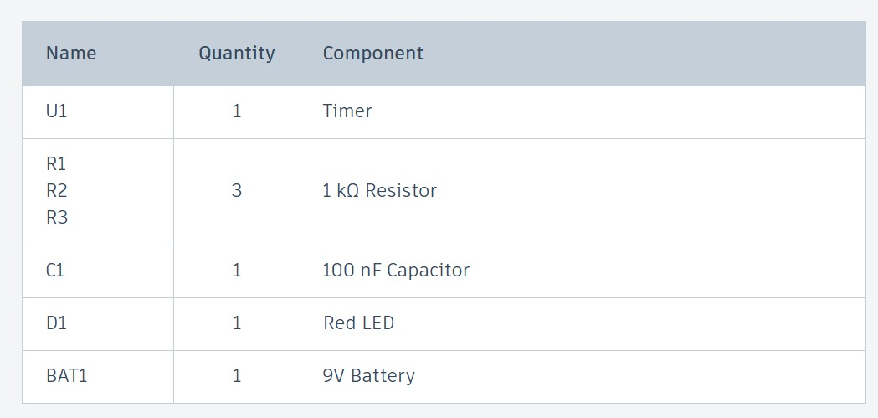

* **CIRCUIT BUILDING ON EASYEDA (2D view) ON PCB BOARD.**
* 

1. **Student Task2 : Analog:4:1 Mux**

### Components Needed

1. **Breadboard:** A standard breadboard to connect all components.
2. **Digital Inputs:**
   * **Switches or Buttons:** 6 switches/buttons (4 for the data inputs and 2 for the select lines).
   * **Pull-down Resistors:** 6 resistors (usually 10k ohm) for each switch/button to ensure a stable logic level when the switch/button is not pressed.
3. **Logic Gates:**
   * **AND Gates:** 4 AND gates to combine data inputs with select lines.
   * **OR Gate:** 1 OR gate to combine the outputs of the AND gates.
   * (Alternatively, you can use a 74xx series IC, such as 74LS153, which contains a 4:1 MUX.)
4. **LED or Digital Output:** 1 LED or digital output pin to visualize the output of the MUX.
5. **Wires:** Jumper wires to connect everything on the breadboard.
6. **Power Source:** 5V power supply (can be from the Tinkercad simulator itself).

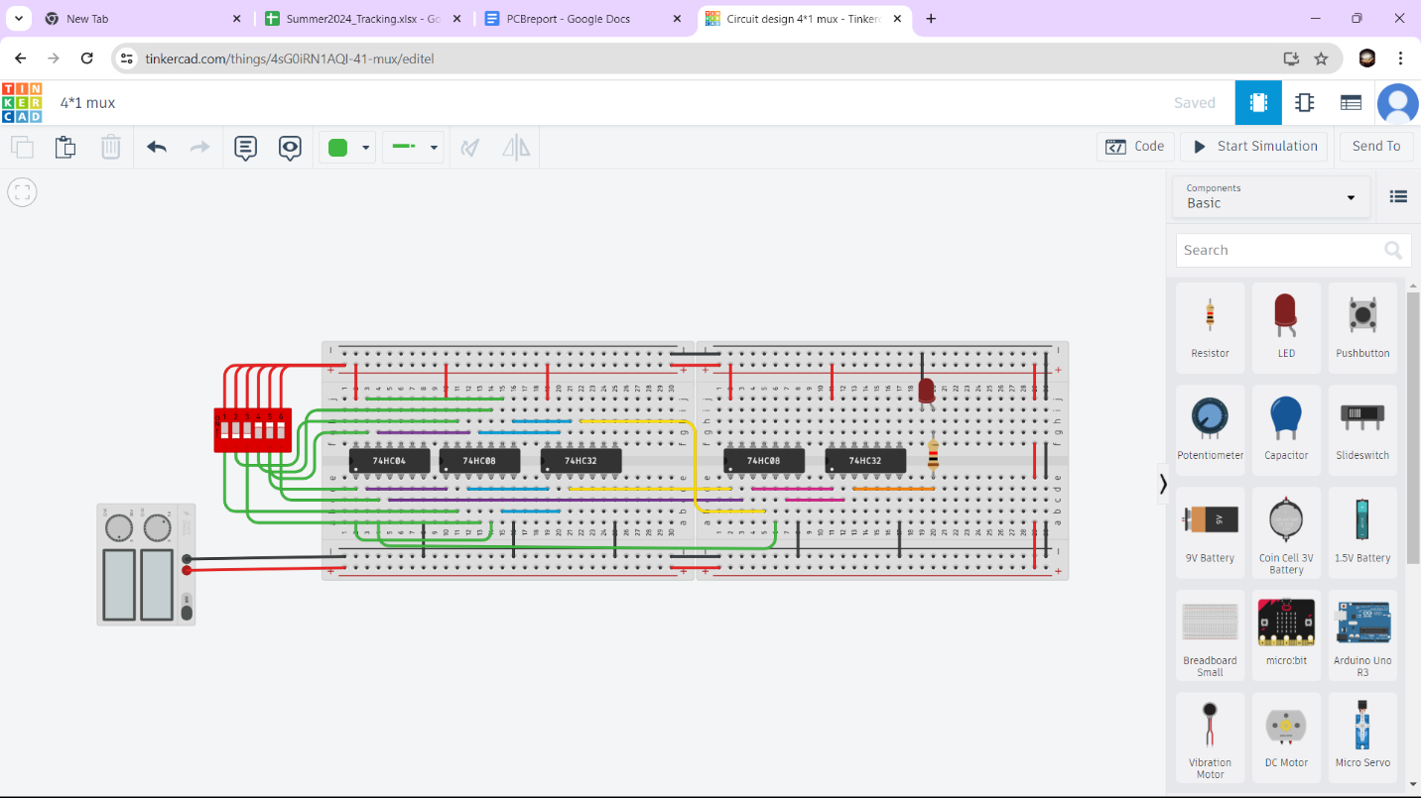

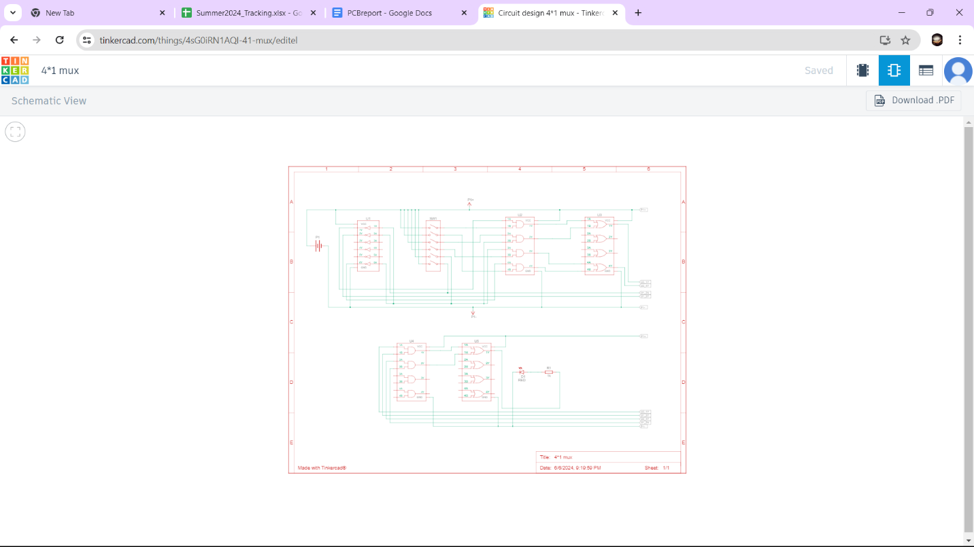



**Hardware Implementation:**

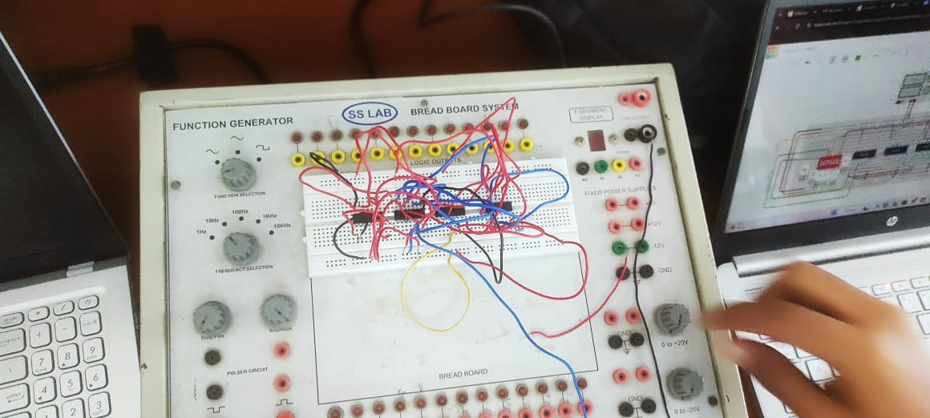

* **CIRCUIT BUILDING ON EASYEDA (2D view) ON PCB BOARD.**

